

***Light-Duty***

***End Yoke Identification***

**End Yoke/U-joint Type ___________**

**Outside Snap Ring (Nubs)**

Nubs cast into yoke that the U-joint caps squeeze

between to retain and center U-joint.

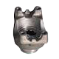 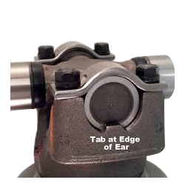

**Inside Snap Ring (No Nubs)**

No nubs cast into the yoke.

The U-joint is retained and centered by the snap

rings that clips on to the U-Joint cap and squeezes

between the ears of the yoke.

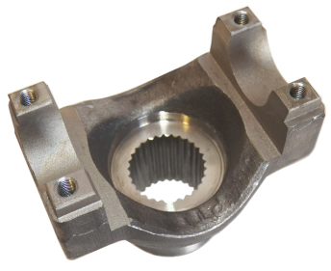 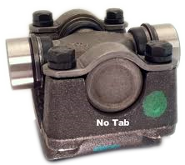

**U-bolt or Strap? ___________**

**U-bolt Strap**

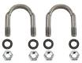 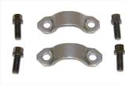

**Spline Count___________**

Count the number of splines.

**Spline Diameter___________**

Measure down in between the splines, straight across.

The largest distance possible.

**Hub Diameter___________**

Measure the outside diameter of the hub where the

seal rides.

**U-Joint Series___________**

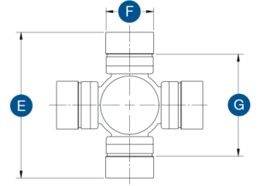

G E F

**Series** *Between* *Between* *Cap*

***Outside SR (nubs)*** *the ears* *the nubs* *Diameter*

1310 3.219 1.062

1330 3.622 1.062

1330 special 3.625 1.125

1350 3.625 1.188

1410 4.188 1.188

1480 4.188 1.375

1550 4.964 1.375

***Inside SR (no nubs)***

3R (GM nylon injected) 2.562 1.125

7260 (Dodge) 2.125 1.078

7290 (Dodge) 2.625 1.125

**Length through the hole__________**

With the Yoke on a table, with the ears pointing up,

measure from where the Nut/Washer hits the yoke

down to the table.

**Center to end__________**

With the Yoke on a table with the ears pointing up.

Measure from the table up to where the center of the

U-joint cap would be.

**Counter bored? __________**

Is the spline counter bored on the hub end?

**Counter bore depth__________**

Measure how deep the spline is machined out from

the end of the Yoke.

**Deflector?** **___________**

Does your Yoke have a metal or plastic shield pressed

on the Yoke, on the hub end?

**Deflector Diameter__________**

What is the outside diameter of the deflector shield